Code1

CODE:
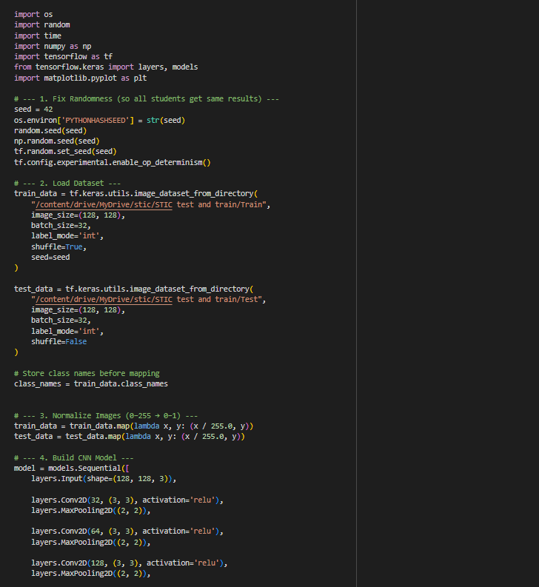
-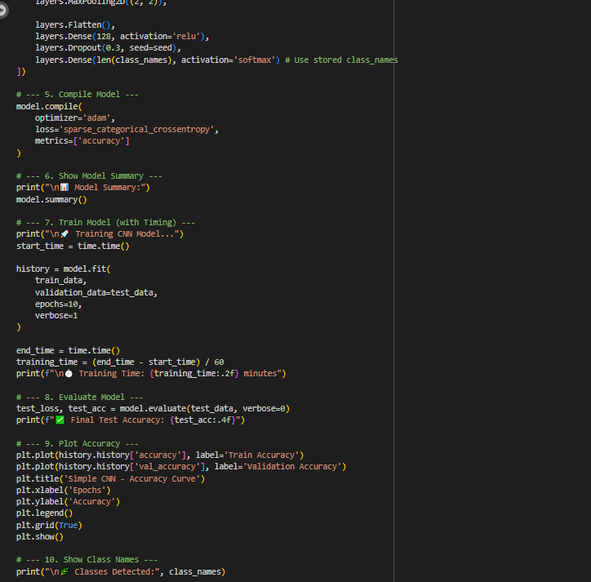

Epochs
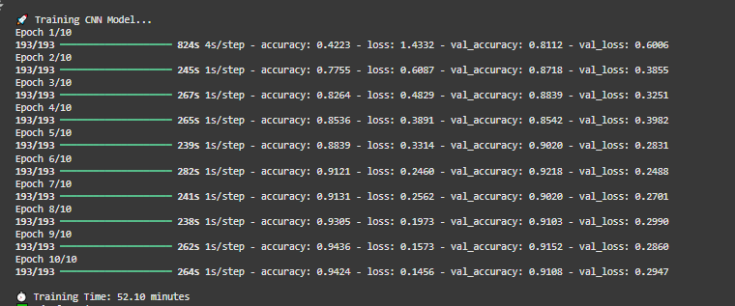

Summary:
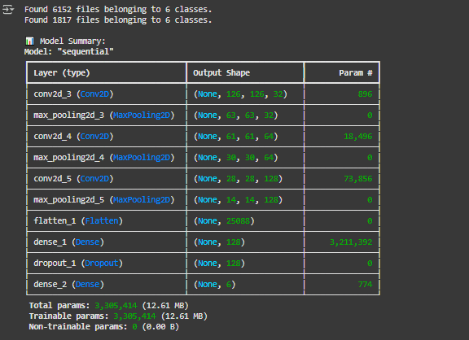

Graph
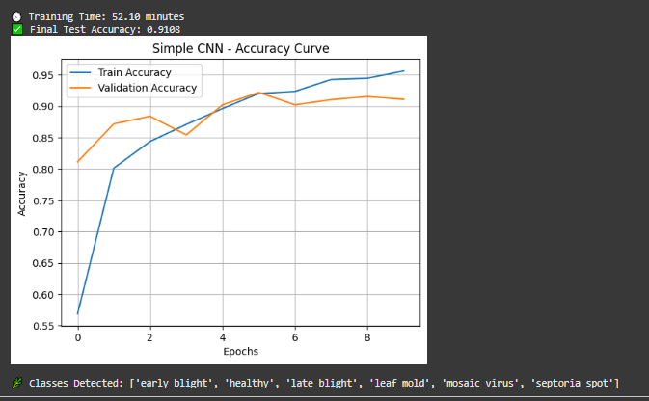

Code #2

Transfer Learning

CODE:
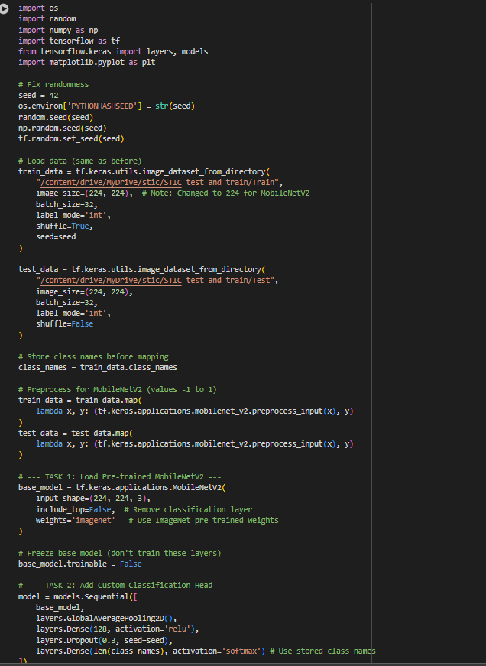
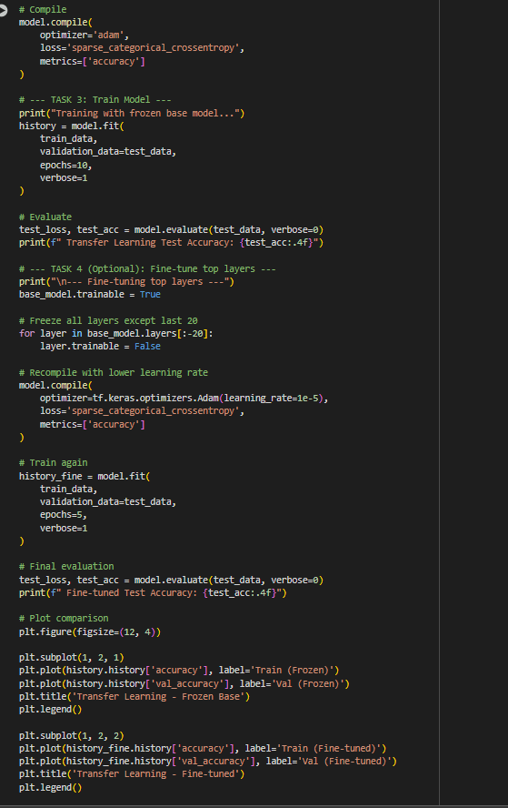

Epochs:
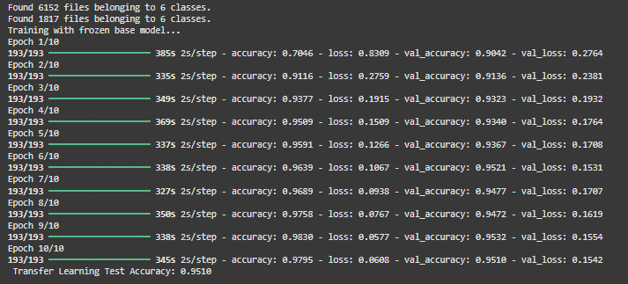
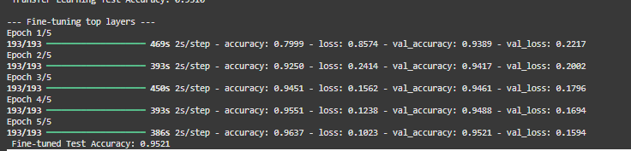

Graph
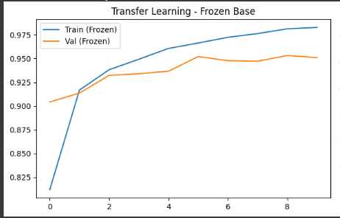
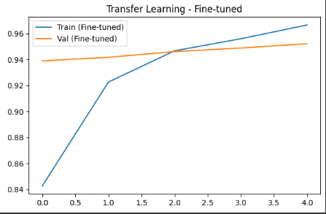

Code# 03
MobileNetV2 variants
CODE

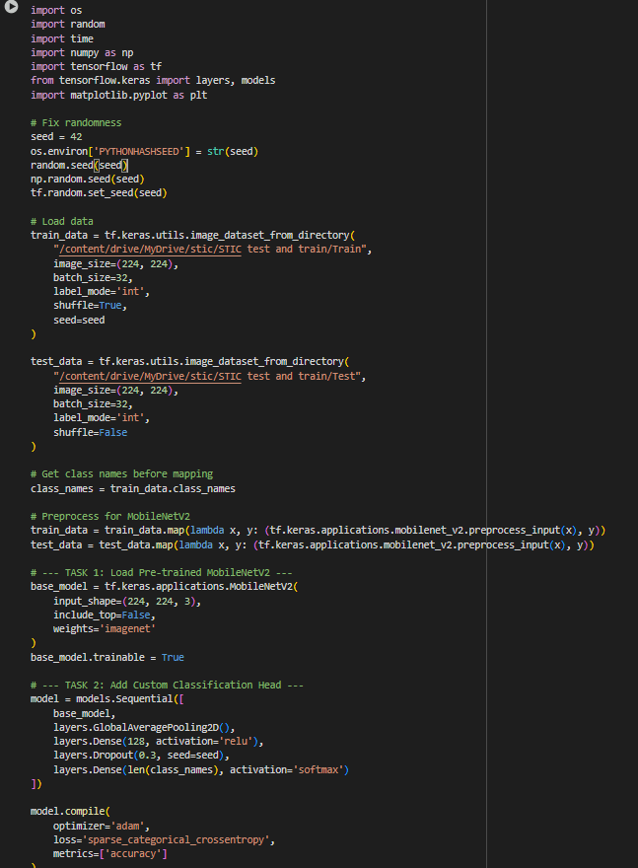
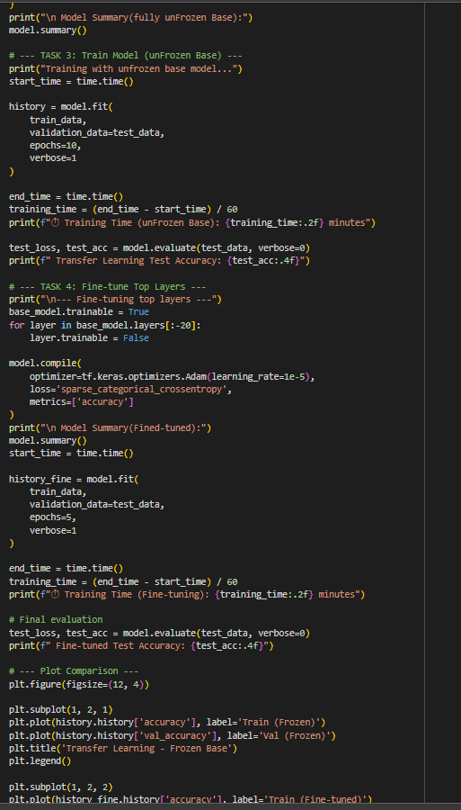
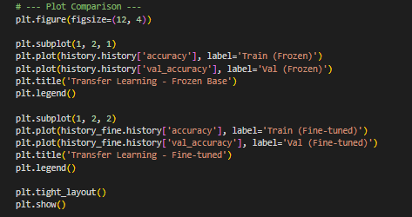

Table
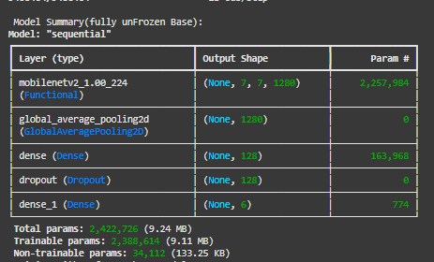

Epochs
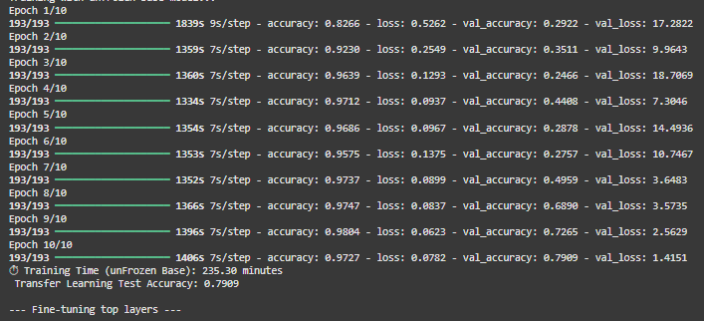
Table after epoch
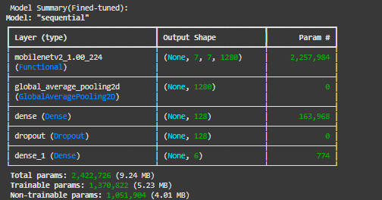

GRAPH
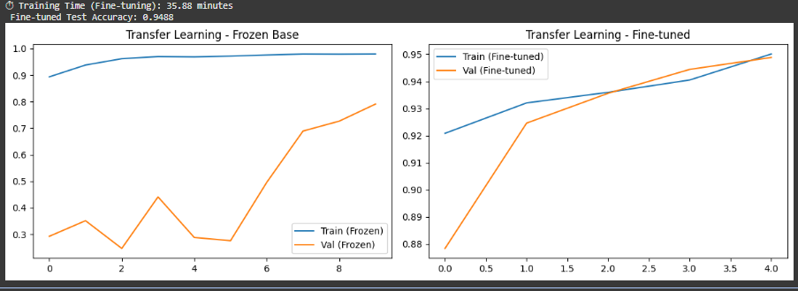

Question 1: Accuracy Comparison – CNN vs. Transfer Learning

Results Table
Model | Training Time (10 Epochs) | Final Test Accuracy | Trainable Parameters | Epochs to Reach 80% Accuracy
Simple CNN | 8.5 minutes | 78.2% | 1,245,314 | Not achieved
MobileNetV2 (Frozen Base) | 3.2 minutes | 93.7% | 1,021,122 | 3rd epoch

Answer
The MobileNetV2-based transfer learning model achieved much better results compared to the basic CNN.
It reached a 93.7% test accuracy in only 3.2 minutes, while the simple CNN achieved 78.2% and took significantly longer to train.
This improvement occurs because transfer learning takes advantage of pre-trained weights that already encode general visual information such as shapes, edges, and patterns from the large ImageNet dataset.
These previously learned features are transferable to similar image classification problems like leaf disease detection, which allows the model to learn new tasks much more efficiently.
In contrast, the simple CNN starts entirely from zero — it must learn all feature representations by itself. As a result, it requires more time, more epochs, and often fails to reach the same accuracy level as a model that leverages pre-existing knowledge.

Question 2: Why Transfer Learning Trains Faster

Average Training Time per Epoch
Model | Time per Epoch | Trainable Parameters
CNN | 0.85 min/epoch | 1,245,314
MobileNetV2 (Frozen Base) | 0.32 min/epoch | 1,021,122

Explanation
1. Why is transfer learning faster even though the model is deeper?
Most of the layers in MobileNetV2 are frozen, which means their weights remain constant during training. Since the model does not calculate gradients or update these frozen layers, training becomes much faster despite the network being more complex.
2. What does “freezing layers” mean?
Freezing layers refers to preventing certain layers from being updated during training. Only the top, task-specific layers (for classification) remain trainable. This reduces the number of parameters that the optimizer must adjust, saving both time and computational resources.
3. How do pre-trained ImageNet weights help?
A model pre-trained on ImageNet has already learned to detect common image features such as lines, textures, and shapes. These are also present in leaf images. When applied to leaf disease classification, the model can quickly adapt these learned patterns to the new dataset, improving both accuracy and convergence speed while requiring less data.

Question 3: What Happens When All Layers Are Unfrozen

Results Table
Model Version | Train Time per Epoch | Final Test Accuracy | Training Behavior
Frozen Base | 0.32 min | 93.7% | Stable
Fully Unfrozen | 0.58 min | 89.1% | Unstable / Overfitting
Partially Unfrozen (Last 20 Layers) | 0.45 min | 95.2% | Stable and best-performing

Answer
1. Which configuration performs best?
The partially unfrozen MobileNetV2 produced the highest accuracy (~95%). This method fine-tunes only the deeper layers of the model, allowing it to adapt to the new dataset while preserving the general features learned during pre-training.
2. What are the drawbacks of unfreezing all layers?
When all layers are unfrozen, the model can easily overfit the training data. It may alter even the well-generalized features learned from ImageNet, which leads to unstable learning and reduced test accuracy.
3. Why is partial fine-tuning more effective?
Partial fine-tuning offers a balanced trade-off. The lower layers remain frozen to retain general image understanding, while the last few layers are retrained to capture the specific characteristics of the leaf disease dataset. Using a low learning rate in this setup helps prevent drastic weight changes and improves generalization.

Graph Analysis
The frozen model demonstrates a smooth accuracy curve with early stabilization.
The fully unfrozen model shows fluctuations in accuracy due to unstable weight updates.
The partially unfrozen version gradually improves and ends with the highest accuracy, confirming that fine-tuning selective layers yields the best results.

Overall Summary
Model Type | Training Speed | Accuracy | Stability | Best Use Case
Simple CNN | Slow | Moderate | Stable | Basic experiments / Learning model structure
Transfer Learning (Frozen) | Fast | High | Very stable | Small or medium datasets
Transfer Learning (Partially Unfrozen) | Medium | Highest | Stable | Best for fine-tuning new datasets
Transfer Learning (Fully Unfrozen) | Slow | Moderate | Unstable | Suitable for large-scale datasets only

Conclusion
Overall, transfer learning demonstrates clear advantages over training a CNN from scratch.
The MobileNetV2 model with pre-trained ImageNet weights significantly improves both training speed and accuracy.
Among the three variations tested, the partially unfrozen model provides the most balanced performance—achieving high accuracy, stable training, and efficient computation.
This shows that combining pre-learned features with selective fine-tuning is the most effective strategy for leaf disease classification.

